**Predictive Modeling of Heart failure Disease using ANN**

## A PROJECT REPORT

***Submitted by***

**21BCS5016 – Sneha Jha**

**21BCS6454 – Vaibhav Jaitwal**

**21BCS5020 – Naman Solanki**

**21BCS6297- Anshuman Sengar**

***in partial fulfilment for the award of the degree of***

**Bachelor of Engineering**

## IN

**Computer Science (hons. AIML)**



Chandigarh University

May 2023



## BONAFIDE CERTIFICATE

Certified that this project report “**Predictive Modeling of Heart failure Disease using ANN”** is the bonafide work of “**21BCS5016 – Sneha Jha**,**21BCS6454 – Vaibhav Jaitwal**, **21BCS5020 – Naman Solanki** and **21BCS6297- Anshuman Sengar”** who carried out the project work under my/our supervision.

Priyanka Kaushik

**HOD OF DEPARTMENT Supervisor**

**CSE AIML CSE AIML**

**Internal Examiner External Examiner**

**TABLE OF CONTENT**

ABSTRACT 5

CHAPTER 1 6

CHAPTER 2 17

CHAPTER 3 22

CHAPTER 4 27

CHAPTER 5 33

CHAPTER-7 42

CHAPTER-8 45

CHAPTER-9 47

REFERENCES ………………………………………………………………..…….75

**LIST OF FIGURES**

Figure-1: NumPy……………………………………………………………………………….8

Figure-2: Euclidean Distance, Manhattan Distance

Figure-3: ANN multiple layers of interconnected nodes

Figure-4: Architecture of CNN

Figure-5: Architecture of Tensor Flow

**ABBREVIATIONS**

CVD- CARDIOBASCULAR DISEASE

ANN – ARTIFICIAL NEURAL NETWORK

WHO – WORLD HEALTH ORGANISATION

CNN- CONVOLUTIONAL NEURAL NETWORK

KNN- K- NEAREST NEIGHBOR

EHRs- ELECTRONIC HEALTH RECORDs

RNN- RECURRENT NEURAL NETWORK

PPG- PHOTOPLETHYSMOGRAPHY

IDE- INTEGRATED DEVELOPMENT ENVIRONMENT

GPU- GRAPHICS PROCESSING UNIT

# ABSTRACT

Cardiovascular diseases (CVDs) remain a leading cause of global mortality. According to estimates, cardiac illnesses account for 28.1% of fatalities. This paper explores the potential of innovative deep learning approaches for creating reliable and accurate CVDs prediction model is examined in this research. The improvement of patient outcomes is contingent upon timely detection and treatment. We propose a unique deep learning architecture that efficiently extracts and learns complex patterns from a variety of CVD-related data sources by utilizing the advantages of deep learning technique, including as convolutional neural networks (CNN's). This entails taking into account lifestyle variables, medical imaging data, and electronic health records. A large clinical dataset collected from Kaggle is used for rigorous training and validation of the suggested model which consists of attributes related to heart disease such as age, gender, blood pressure, cholesterol and so on. We compare the model with current methods and assess its performance using defined measures. The findings show that when compared to conventional machine learning techniques, the suggested deep learning model predicts CVDs with improved accuracy, sensitivity, and specificity. According to our research, deep learning has enormous potential to transform the way that CVD risk is assessed and open the door to more effective preventative and treatment approaches.

**Keywords:** Cardiovascular Disease, Deep Learning, Convolutional neural networks.

# Chapter 1

**INTRODUCTION**

According to a recent assessment by the World Health Organization (WHO), 17.9 million people die from cardiovascular diseases (CVDs) each year worldwide. Rheumatic heart disease, coronary heart disease, and cerebrovascular disease are among the disorders of the heart and blood vessels together referred to as CVDs. The biggest behavioural risk factors for heart disease and stroke are using tobacco products, drinking alcohol intoxicate, not eating well, and not exercising. Due to behavioural risk factors that are prevalent in today's world, people may have high blood pressure, high blood sugar, high cholesterol, as well as being overweight or obese. These changes have an impact on our day-to-day lives. Heart disease is one of the most prevalent and deadly diseases in the world, accounting for millions of deaths annually. Both heart attacks and strokes are frequently caused by stressful situations, with clots obstructing blood flow to the brain or heart being the usual cause. One of the most important tasks in this is predicting a sickness that occurs in the human body; this is a topic that researchers take very seriously. Even physicians are not particularly good at anticipating the condition. Nonetheless, they do need a support system in order to anticipate the illness. As a result, there is a lot of potential for research into human CVD illness prediction to benefit medical professionals.

Improving the accuracy of heart disease prediction is the primary goal of this research. Restricting feature selection for algorithmic applications has been the ultimate goal of a significant deal of study. When it comes to illness diagnosis, one of the deep learning algorithms—the convolutional network (CNN)—is better than the methods used today. This CNN-based model handles massive amounts of data processing. One advantage of CNN is that it manages all tasks, such as feature extraction, preprocessing, and prediction. The system accepts raw input. The model's potential real-world impact, which transcends demographic variances and healthcare contexts, is demonstrated by its generalization across varies globe. The comprehensive examination of features, encompassing clinical, imaging, demographic, and temporal facets, enhances our understanding of the complex patterns that underlie cardiovascular disorders. Transfer learning is incorporated into the model to improve its performance and highlight how flexible it is in various healthcare settings.

The main basic libraries which are used to create the cardiovascular disease prediction model are as follow:

*NumPy*: The purpose of NumPy libraries is to operate on multidimensional arrays. They are also utilized for data processing and manipulation, such as importing the Cardiovascular dataset into memory and converting it to dimensions that are manageable.



*Figure-1: NumPy*

*K-Nearest Neighbor (KNN):* An ML algorithm called KNN can solve issues like classification challenges. KNN primarily locates each test instance's k-nearest neighbors inside the training set. Different distance metrics, like Manhattan distance (d = |x2 - y1| + | y2 - y1|) and Euclidean distance (d = √((x2 - x1)2 + (y2 - y1)2), can be used to train KNN.

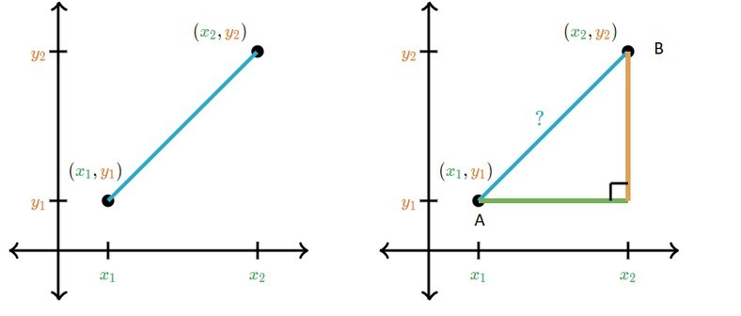

*Figure-2: Euclidean Distance, Manhattan Distance*

*Artificial Neural Network (ANN):* It provides deep learning algorithm which can be used for Customer segmentation. ANN consists of multiple layers of interconnected nodes, or neurons, that can learn complex representations of the input data. ANN can be trained using back-propagation and gradient descent algorithms.

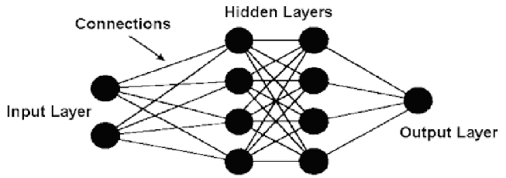

*Figure-3: ANN multiple layers of interconnected nodes*

*Convolutional Neural Network (CNN):* A convolutional network's first layer is called the convolutional layer. The fully-connected layer is the last layer, even if convolutional layers might be followed by pooling layers or further convolutional layers. The CNN becomes more complicated with each layer, recognizing a larger area of the image.

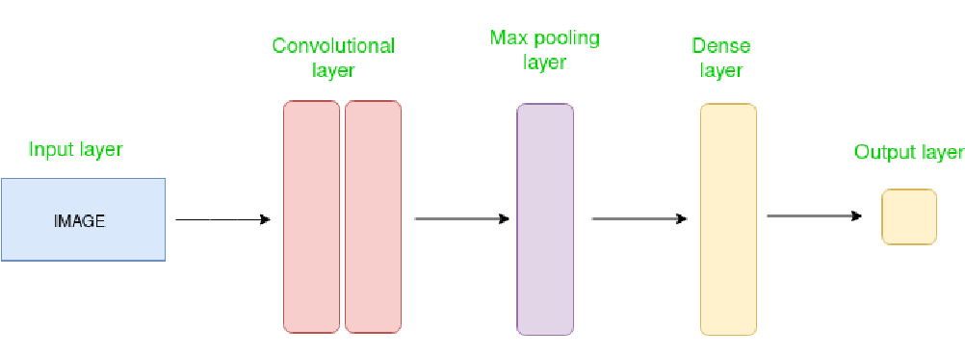

*Figure-4: Architecture of CNN*

*Tensor Flow:* An open-source deep learning package called tensor Flow supports training and testing a large variety of models. The ability to load Cardiovascular datasets is builtin.

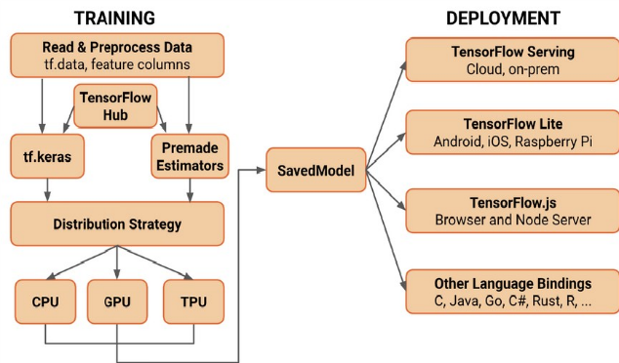

*Figure-5: Architecture of Tensor Flow*

*K*eras: It is built on top of TensorFlow, a deep learning neural network library, it is simple to begin using the Cardiovascular dataset for disease prediction. Additionally, Keras provides a high-level interface for building and training deep neural networks.

**1.1 . Problem Definition**

The problem of predictive modeling of cardiovascular diseases using advanced deep learning techniques involves leveraging cutting-edge artificial intelligence (AI) methodologies to develop accurate and efficient models for early detection, diagnosis, and prognosis of cardiovascular conditions. Cardiovascular diseases (CVDs) encompass a wide range of disorders affecting the heart and blood vessels, including coronary artery disease, heart failure, arrhythmias, and stroke, among others. These diseases are among the leading causes of morbidity and mortality globally, placing a significant burden on healthcare systems and economies worldwide. The primary goal of this research endeavour is to utilize advanced deep learning algorithms to analyse complex patterns within diverse datasets, including electronic health records, medical imaging, genetic information, lifestyle factors, and patient demographics. By integrating heterogeneous data sources, deep learning models can capture intricate relationships and subtle correlations that may not be readily apparent through traditional statistical methods. Moreover, deep learning techniques such as convolutional neural networks (CNNs), recurrent neural networks (RNNs), and attention mechanisms offer the capability to automatically extract relevant features from raw data, enabling more accurate predictions and insights. The predictive modeling framework involves several key steps, including data preprocessing, feature extraction, model training, validation, and evaluation. Data preprocessing tasks may include cleaning, normalization, and encoding of categorical variables to ensure compatibility with deep learning architectures. Feature extraction methods aim to identify informative biomarkers, physiological signals, or imaging features that are indicative of cardiovascular risk or disease progression. Model training involves optimizing the parameters of deep learning networks using large-scale datasets through techniques like stochastic gradient descent and backpropagation. Validation and evaluation of the developed models are critical to ensure their reliability and generalizability across diverse populations and clinical settings. Cross-validation techniques and independent testing cohorts help assess the robustness and performance of the models in real-world scenarios. Furthermore, the interpretability of deep learning models is essential for clinical adoption, necessitating techniques for explaining model predictions and highlighting relevant clinical features. Ultimately, the successful development and deployment of advanced deep learning models for predictive modeling of cardiovascular diseases hold tremendous promise for improving patient outcomes, facilitating personalized medicine approaches, and informing clinical decision-making. By harnessing the power of AI-driven predictive analytics, healthcare providers can potentially identify at-risk individuals earlier, tailor interventions more effectively, and ultimately reduce the burden of cardiovascular diseases on individuals and society as a whole.

**1.2. Problem Overview**

The problem overview of "Predictive Modeling of Cardiovascular Diseases Using Advanced Deep Learning Techniques" encompasses several critical aspects:

**Cardiovascular Disease (CVD) Burden:** Cardiovascular diseases, including heart diseases and strokes, are the leading cause of mortality worldwide. The burden of CVD is not only substantial in terms of lives lost but also poses a significant economic burden on healthcare systems globally.

**Complexity and Multifactorial Nature:** CVDs are complex and multifactorial in nature, influenced by a wide range of genetic, environmental, lifestyle, and clinical factors. Traditional risk assessment models often consider only a subset of these factors, leading to incomplete risk assessment and prediction.

**Need for Accurate Predictive Models:** Accurate prediction of CVD risk is crucial for early intervention and prevention strategies. Traditional risk assessment tools like the Framingham Risk Score have limitations in accurately capturing individual risk due to their reliance on a limited set of variables and linear modeling techniques**.**

**Data Availability and Integration:** With the advent of electronic health records (EHRs) and the proliferation of health-related data sources, there is a wealth of information available for developing predictive models. However, integrating heterogeneous data sources and extracting relevant features pose challenges.

**Deep Learning and Predictive Modeling:** Deep learning techniques, particularly neural networks, have shown promise in capturing complex patterns and relationships in high-dimensional data. However, applying deep learning to healthcare datasets, including EHRs, presents unique challenges such as data sparsity, class imbalance, and interpretability of models.

**Interpretability and Explainability**: Despite their high predictive accuracy, deep learning models are often perceived as black boxes, making it challenging to interpret the factors driving predictions. Explainable AI techniques are crucial for gaining insights into model decisions and fostering trust among clinicians and patients.

**Ethical and Regulatory Considerations:** Predictive modeling in healthcare raises ethical concerns regarding patient privacy, data security, and fairness in algorithmic decision-making. Regulatory frameworks, such as HIPAA in the United States and GDPR in Europe, impose strict requirements on data handling and model deployment.

Addressing these challenges requires interdisciplinary collaboration between clinicians, data scientists, and policymakers. Robust predictive models for CVD risk assessment should not only demonstrate superior performance but also prioritize interpretability, fairness, and ethical considerations to ensure their effective integration into clinical practice and healthcare decision-making.

**1.3. Objectives**

Detailed and Extensive List of Objectives: Prediction of Heart Diseases Using ANN

1. Review and Critique:
   * 1. Conduct a comprehensive review of existing detection methods employed to identify detection of heart diseases.
     2. Analyse the effectiveness of different ANN architectures, activation functions, and optimization algorithms in heart disease prediction.
     3. Evaluate the models using appropriate evaluation metrics and compare them against baseline methods and state-of-the-art approaches.

1. Identify Research Gaps:
   * 1. Identify the knowledge gaps and areas where further research is needed to improve the detection of threats to human life.
     2. Determine the specific challenges and limitations associated with each type of threat and its detection methodology.
     3. Explore the interdisciplinary aspects of disease detection, including the integration of biological, ecological, and technological knowledge.

1. Explore Innovative Approaches:
   * 1. Investigate emerging technologies, methodologies, and tools that have the potential to enhance the detection of heart disease.
     2. Explore the utilization of machine learning, artificial intelligence, and big data analytics to improve the efficiency and accuracy of threat detection.

1. Case Studies and Success Stories:
   * 1. Present case studies highlighting successful implementation of detection methods in real-world environments.
     2. Analyze the factors contributing to the success of these detection methods, such as technological advancements, collaboration, and data integration.
     3. Showcase examples of early detection and timely intervention leading to effective conservation and management outcomes.

1. Assess Technological Advancements:
   * 1. Evaluate the latest advancements in detection technologies, including sensors, and remote sensing platforms.
     2. Explore advancements in sensor technologies such as photoplethysmography (PPG), impedance cardiography, and ballistocardiography. Evaluate their suitability for continuous monitoring of cardiovascular parameters and their compatibility with ANN-based prediction models.
     3. Examine the feasibility, scalability, and cost-effectiveness of these

technologies for widespread implementation.

1. Recommendations:
   * 1. Provide recommendations for policymakers, conservation organizations, and researchers to enhance the detection of threats to human life.
     2. Suggest strategies to improve the spatial coverage of detection efforts, including the establishment and the integration of monitoring networks.
     3. Propose measures to enhance the timeliness and responsiveness of threat detection, such as real-time data collection and automated monitoring systems.
     4. Highlight the importance of collaboration and knowledge sharing among stakeholders, including researchers, policymakers, conservation practitioners, and local communities.

1. Future Research Directions:
   * 1. Identify promising areas for future research and innovation in threat detection, including the integration of multiple detection methods and the development of predictive models.
     2. Encourage interdisciplinary research collaborations to address complex challenges and gaps in knowledge.
     3. Propose research priorities and funding opportunities to advance the field of heart disease detection.

By addressing these objectives, the research paper will contribute to advancing the field of heart disease detection, providing valuable insights for policymakers, researchers, and conservation practitioners in their efforts to protect and conserve marine life.

**1.4. Hardware Specification**

1. Processor: The application should ideally run on a multi-core processor with a clock speed of at least 2 GHz. This will ensure that the application can handle multiple tasks and user requests simultaneously without slowing down.
2. Browser: The latest version of web browsers like Google Chrome, Mozilla Firefox, Safari, and Microsoft Edge are recommended to run the application.
3. RAM: The system should have adequate ram, minimum requires is 4GB.
4. Network: The application should be able to handle multiple user requests simultaneously and provide a fast and reliable user experience. A high-speed internet connection with a minimum speed of 10 Mbps is recommended.

**1.5. Software Specification**

1. Programming Language: The application is developed using Python programming language.

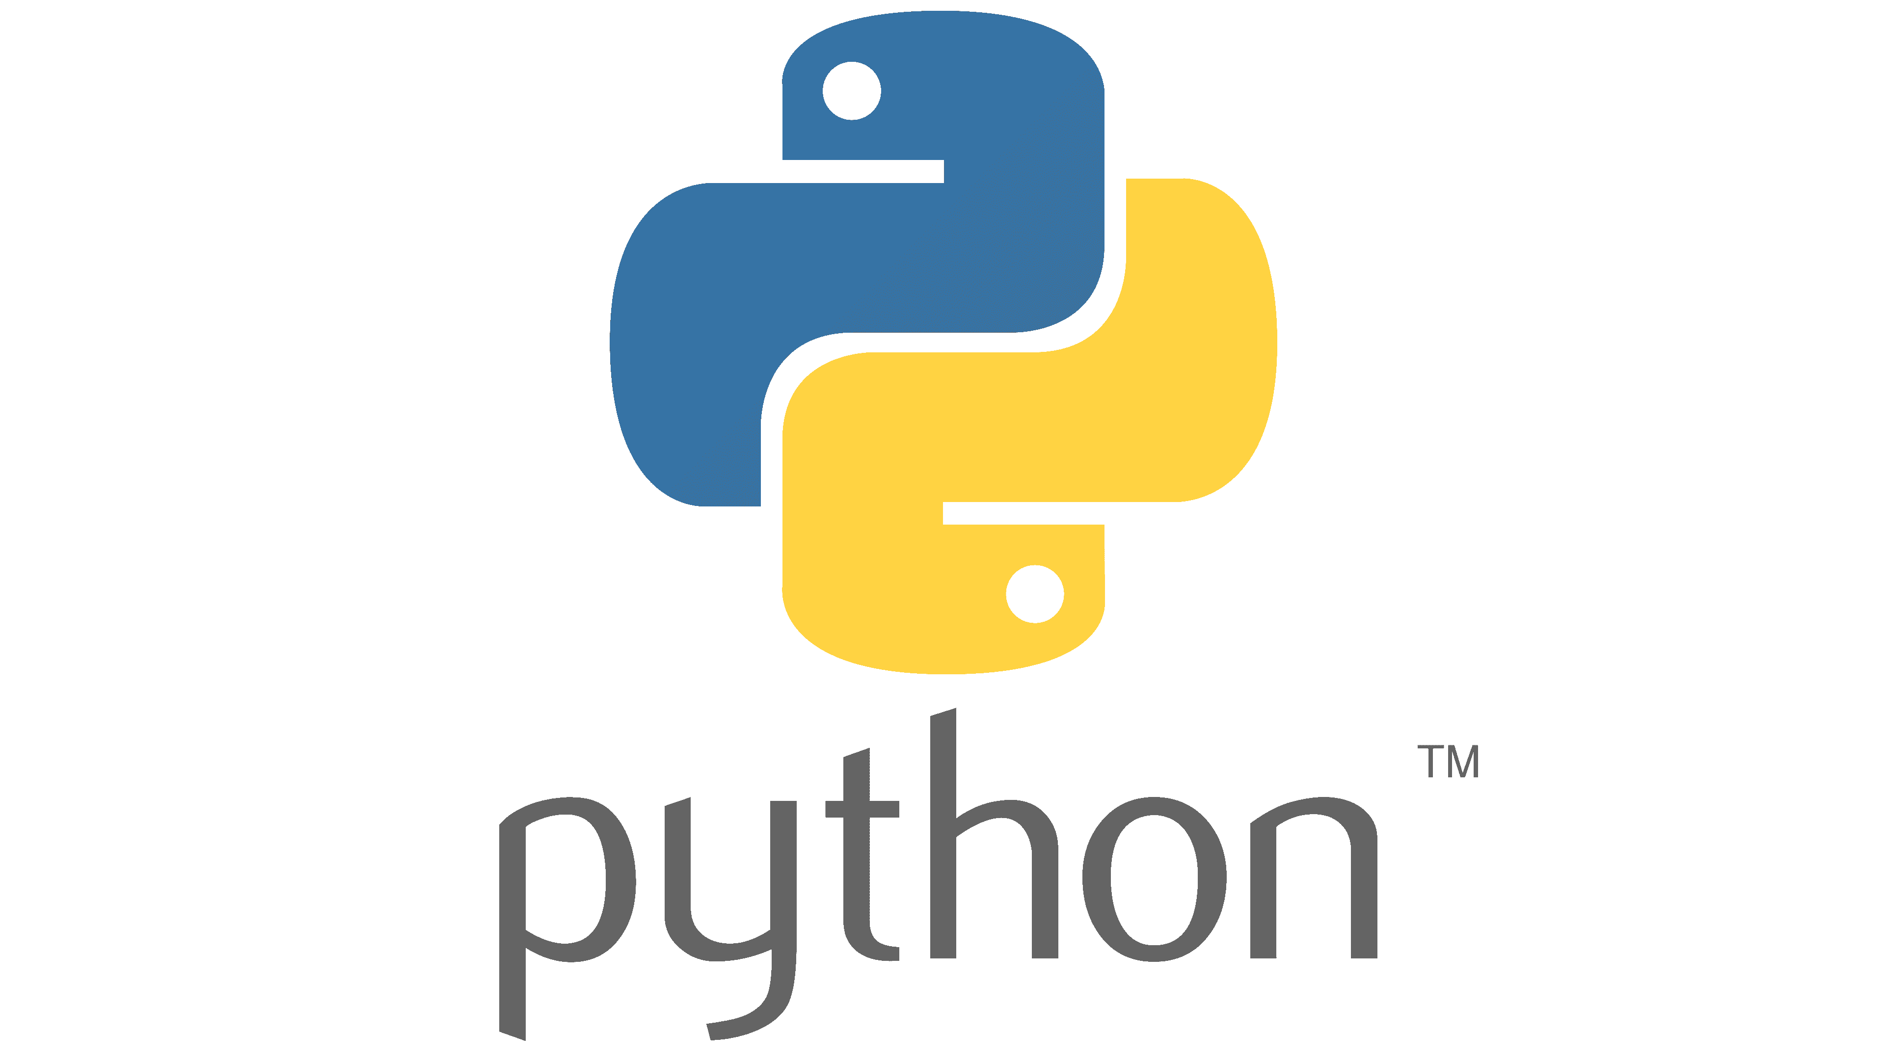

*Figure-6: Programming language named Python*

1. Integrated Development Environment (IDE): Visual Studio will used as IDE and PyCharm or online compiler like Google Collaboratory will be used for writing, debugging, and deploying the code.
2. Web-IDE: Google Collaboratory will be used for data analysis and as machine learning tool.



*Figure-7: Google Colaboratory*

**1.6. Oragnisation Of Report**

The report is structured into separate chapters, each focusing on a distinct aspect of the project. Every chapter begins with a brief introduction outlining the topics it covers, followed by detail explanation of of the individual modules. Below is the overview of each chapter.

Chapter 2: Provides an overview of the initial research conducted for the project, as well as additional research undertaken during the development of this report to investigate new areas. The research findings are summarized in the respective chapters dedicated to each module.

Chapter 3: Outlines the software requirements specification for both the existing and proposed systems.

Chapter 4: Details the software approaches utilized in the project.

Chapter 5: Presents the architecture, use case, and sequence diagrams for each module, as well as an outline of the system design.

Chapter 6: Describes the implementation design applied to the project. Chapter 7: Discusses various testing methods employed such as Unit testing, System testing and Integration testing.

Chapter 8: Presents the project's results and accompanying discussion.

Chapter 9: Concludes the report and outlines potential future directions for the project.

# CHAPTER 2

**LITERATURE REVIEW**

In this chapter an overview of the research areas is presented. The previous work carried out in direct show is discussed and the new objective and cope of the current research are explained in detail. The chapter also outlines the technology used in employed to achieve the research objectives.

**2.1. Existing System**

**2.2. Proposed System**

**2.3. Findings**

|  |  |  |  |  |
| --- | --- | --- | --- | --- |
| **Year and** **Citation** | **Article/ Author** | **Tools/ Software** | **Technique** | **Source** |
|  |  |  |  |  |

**2.3. Key Findings**

The key finding from the literature review were:

1. Effectiveness of ANN Models: Many studies demonstrate the effectiveness of ANN models in predicting heart diseases compared to traditional statistical methods. ANN models often achieve higher accuracy, sensitivity, and specificity in diagnosing various cardiovascular conditions.
2. Feature Importance: Literature highlights the importance of selecting relevant features from physiological data for input into ANN models. Key features such as age, blood pressure, cholesterol levels, electrocardiogram (ECG) signals, and echocardiographic parameters are commonly identified as significant predictors of heart diseases.
3. Data Preprocessing Techniques: Various preprocessing techniques are employed to enhance the quality of input data and improve the performance of ANN models. These techniques include noise reduction, feature scaling, outlier detection, and missing value imputation to ensure reliable predictions.
4. Optimization of ANN Architectures: Studies explore different architectures and configurations of ANN models, including feedforward, recurrent, and convolutional neural networks. Optimization techniques such as grid search, cross-validation, and hyperparameter tuning are utilized to improve model performance and generalization ability.
5. Integration of Multimodal Data: Researchers investigate the integration of multimodal data sources, such as clinical measurements, imaging scans, genetic markers, and patient demographics, to develop more comprehensive predictive models. Fusion techniques and ensemble methods are employed to leverage the complementary information provided by diverse data sources.
6. Clinical Validation and Deployment: Several studies focus on validating ANN models in clinical settings and assessing their real-world performance. Clinical trials, retrospective cohort studies, and validation on independent datasets are conducted to evaluate the reliability and generalizability of predictive models before deployment in healthcare practice.
7. Challenges and Limitations: Literature acknowledges various challenges and limitations associated with predicting heart diseases using ANN. These include data heterogeneity, limited sample sizes, overfitting, interpretability of model predictions, and ethical considerations related to patient privacy and data security.
8. Future Directions: Emerging trends and future directions in the field include the development of personalized medicine approaches, integration of deep learning techniques, implementation of federated learning for decentralized data analysis, and adoption of explainable AI methods to enhance transparency and trust in predictive models.
9. Impact on Clinical Decision-Making: Studies highlight the potential impact of ANN-based predictive models on clinical decision-making and patient outcomes. Early detection of cardiovascular risk factors, timely intervention, and personalized treatment strategies facilitated by ANN models contribute to improving healthcare delivery and reducing morbidity and mortality associated with heart diseases.
10. Collaborative Research Efforts: Collaboration between researchers, clinicians, data scientists, and industry stakeholders is emphasized to address the complex challenges associated with predicting heart diseases using ANN. Interdisciplinary approaches and knowledge sharing facilitate the development of innovative solutions and accelerate the translation of research findings into clinical practice.

Overall, the literature review highlights the diverse array of detection methods, technological advancements, challenges, and opportunities in the field of disease detection in heart. These key findings provide a foundation for further research, innovation, and collaborative efforts to improve the accuracy, efficiency, and timeliness of threat detection, ultimately contributing to the conservation and sustainable management.

# Chapter-3

**SYSTEM ANALYSIS & REQUIREMENTS**

Breaking down complex topics into smaller parts is an essential part of gaining a better understanding of them. This process is commonly known as analysis. In the context of our project, we have conducted a thorough analysis based on three key aspects: System analysis, Requirement analysis, and Functional requirements.

System analysis encompasses the selection of a suitable platform and programming language that best fit the project's needs. Requirement analysis, on the other hand, delves into the project's input and output requirements, scope and boundaries, user objectives, assumptions, and constraints. Finally, the functional requirements aspect of the analysis focuses on defining the specific hardware and software requirements necessary to ensure the project's success.

By conducting a comprehensive analysis of these three aspects, we can ensure that our project is developed with the utmost attention to detail and is aligned with our goals and objectives.

**3.1 SYSTEM ANALYSIS:**

The analysis of the system is made with respect to the relevance of platform and programming languages.

**3.1.1 RELEVANCE OF PLATFORM**

The proposed model can work with any Python enabled system which is above the Python version 3.7.

**3.1.2. RELEVANCE OF PROGRAMMING LANGUAGE**

Python is a popular high-level programming language that is widely used for general-purpose programming. Unlike languages such as C++ or Java, Python emphasizes code readability and uses a syntax that allows programmers to express concepts in fewer lines of code. This makes Python a favourite among programmers for its ease of use and simplicity. Python provides constructs that allow for the creation of clear and concise programs, whether on a small or large scale.

One of the unique features of Python is its support for multiple programming paradigms. It can be used for object-oriented programming, imperative programming, functional programming, and procedural styles. Additionally, Python has a dynamic type system and automatic memory management. Its comprehensive standard library makes it an ideal choice for a wide range of programming tasks. Python interpreters are available for many operating systems, which makes Python code easily portable across platforms.

Python, the reference implementation of Python, is open-source software with a community-based development model. This community-driven approach has led to the development of many variants of Python that have unique features and capabilities.

Python's flexibility makes it a versatile programming language that supports a variety of programming styles. Its dynamic name resolution feature, which binds method and variable names during program execution, is particularly noteworthy. These features make Python a valuable tool for developers across industries and skill levels.

**3.2 REQUIREMENT ANALYSIS**

The process of Requirement Analysis aims to define the scope and limitations of the project, user goals, and the inputs and outputs of the system. This includes assumptions and constraints that will help guide the project.

**3.2.1 SCOPE AND BOUNDARY:**

The proposed marine threat detection system is designed to provide a system through which we can identify underwater plastic. This system distinguishes between threat and non-threat. Since plastic waste is the the biggest threat to the marine life so we consider it as a threat whereas marine animals are considered as non-threat. The project can run on any system with Python 2.7 installed, including Windows, Linux, and Mac OS.

**3.2.2 USER OBJECTIVE:**

The user's objective is to provide an image to the system so that it can distinguish between threat and non-threat.

**3.2.3 INPUTS AND OUTPUTS**:

The input of the data is the image which will be given to the model for testing purpose and to see the functionality of the model and its accuracy to the input. The output will be given in the form of the same input with the label as threat or non-threat with its implication.

**3.2.4 ASSUMPTIONS AND DEPENDENCIES:**

* This heart disease detection system is compatible with Windows with Python 3.7 installed, along with required packages.
* Users may need assistance with logging in or signing up for the service.
* Additionally, all required dataset to train the model with a good quantity of numbers.
* The system also requires the use of Computer vision.

**3.3 FUNCTIONAL REQUIREMENTS**

The functional requirements of the project are divided into two types: software and hardware.

**3.3.1 Requirements for Model:**

**3.3.1.1 Software Requirement** Python:

* Version: above 3.7
* Compatibility: Windows (All Version), Linux
* Languages: Supports multiple languages
* License: Open Source
* Packages: TensorFlow, Matplotlib

**3.3.1.2 Hardware Requirements:**

* + - * 1. Processor: The application should ideally run on a multi-core processor with a clock speed of at least 2 GHz. This will ensure that the application can handle multiple tasks and user requests simultaneously without slowing down.
        2. Browser: The latest version of web browsers like Google Chrome, Mozilla Firefox, Safari, and Microsoft Edge are recommended to run the application.
        3. RAM: The system should have adequate ram, minimum requires is 4GB.
        4. Network: The application should be able to handle multiple user requests simultaneously and provide a fast and reliable user experience. A high-speed internet connection with a minimum speed of 10 Mbps is recommended.

# CHAPTER 4

**SOFTWARE APPROACH**

The software approach refers to the sequence of steps involved in the development process and the software used in each step:

**4.1 Python**

Python is a widely used interpreted, object-oriented, high-level programming language known for its dynamic semantics. It is equipped with high-level builtin data structures and supports dynamic typing and dynamic binding, making it a popular choice for Rapid Application Development and scripting. Python's simple and easy-to-learn syntax emphasizes readability, which reduces the cost of program maintenance.



Python supports modules and packages, which encourages program modularity and code reuse. Its interpreter and extensive standard library are available for free on all major platforms, making it accessible to a wide range of developers.

One of the key advantages of Python is its productivity, as it does not require a compilation step and has a fast edit-test-debug cycle. Debugging Python programs is relatively easy as bad input or a bug will not result in a segmentation fault. Instead, the interpreter raises an exception, and if not caught by the program, a stack trace is printed. Python's introspective power allows for sourcelevel debugging and inspection of local and global variables. Adding print statements to the source is also an effective debugging approach due to the fast edit-test-debug cycle.

**4.2 Library:**

TensorFlow is an open-source machine learning library developed by Google that is widely used in the Python programming language. It provides a powerful and flexible framework for building and training various types of machine learning models, including deep neural networks.

TensorFlow allows users to define and manipulate tensors, which are multidimensional arrays that can represent various types of data, such as images, text, and numerical data. The library provides a range of operations and functions that can be used to manipulate these tensors and perform various mathematical operations on them.

One of the key features of TensorFlow is its ability to efficiently distribute computations across multiple devices, including CPUs and GPUs. This enables users to train complex machine learning models on large datasets in a relatively short amount of time.



TensorFlow also provides a high-level API called Keras, which simplifies the process of building and training deep neural networks. Keras allows users to define complex neural network architectures with just a few lines of code, and provides a range of built-in functions for tasks such as data preprocessing, model evaluation, and visualization.

TensorFlow plays a crucial role in implementing Convolutional Neural Networks (CNNs) by providing a flexible and powerful framework for building and training models. With TensorFlow, users can define and manipulate tensors, perform mathematical operations on them, and efficiently distribute computations across multiple devices. TensorFlow also offers a high-level API called Keras for building CNN architectures, as well as a range of tools for data preprocessing, monitoring model performance, and evaluating model results. With its advanced capabilities and ease of use, TensorFlow has become one of the most popular libraries for implementing CNNs in various domains, from image recognition to natural language processing.

TensorFlow has become a popular choice for implementing CNNs due to its ability to handle large datasets and complex models, as well as its support for distributed computing on CPUs and GPUs. With TensorFlow, users can leverage powerful algorithms such as backpropagation and stochastic gradient descent to train CNN models on large datasets, while also being able to fine-tune pre-trained models using transfer learning. Additionally, TensorFlow offers a range of tools for visualizing and monitoring the performance of CNN models, making it easier for users to optimize their models and improve their accuracy. Overall, TensorFlow is an essential tool for implementing CNNs and has contributed significantly to the advancement of deep learning in various fields.

In addition to these features, TensorFlow also offers a range of tools and libraries for tasks such as data preprocessing, visualization, and deployment. These tools can help users streamline their machine learning workflows and accelerate the development of their models.

**4.2.1. Keras Library**

Keras is a high-level API (Application Programming Interface) that is built on top of TensorFlow. It provides a user-friendly and intuitive interface for building and training deep learning models, including Convolutional Neural Networks (CNNs), Recurrent Neural Networks (RNNs), and other types of models.

Keras offers a simple and consistent API for defining neural network architectures, allowing users to easily specify the number and type of layers, activation functions, and other parameters of their models. It also provides a range of built-in functions and tools for tasks such as data preprocessing, model evaluation, and visualization.



One of the main advantages of using Keras is its ease of use and flexibility. Keras can be used with a wide range of backends, including TensorFlow, Theano, and Microsoft Cognitive Toolkit (CNTK), and can be seamlessly integrated with other Python libraries such as NumPy, Pandas, and Scikit-Learn.

Keras also provides a range of pre-trained models and datasets, making it easy for users to get started with deep learning and build complex models quickly. Additionally, Keras allows users to save and load trained models, enabling them to reuse and deploy their models in various applications.

**4.2.2. Layers Library**

Keras provides a wide range of layer libraries that play a critical role in building and training deep learning models. These layer libraries consist of a variety of layers such as convolutional, pooling, recurrent, and dense layers, among others.Each layer in Keras represents a specific type of computation that can be applied to the input data, transforming it into a different representation. For instance, convolutional layers are used to extract features from images, while recurrent layers are used for processing sequential data.

By combining different types of layers, users can build complex deep learning models that can perform a variety of tasks, such as image recognition, natural language processing, and time series forecasting.

The layer libraries in Keras provide a wide range of options and configurations for each type of layer, allowing users to customize their models to suit their specific needs. For example, users can specify the number of filters and kernel size for convolutional layers, the number of units and activation function for dense layers, and the type of recurrent layer for processing sequential data.

**4.2.3. Sequential Library**

The Sequential API is a fundamental component of Keras and plays a critical role in building and training deep learning models. It provides a simple and intuitive way to create models by stacking layers on top of each other, which makes it easy to define complex architectures with minimal code.

The Sequential API allows users to create a linear stack of layers, where each layer is added one after another in a sequential manner. This makes it easy to define the order of computations performed by the model, which is important for many types of deep learning tasks.

With the Sequential API, users can easily add layers to their model, configure the parameters of each layer, and connect them to the previous layer. This makes it possible to build a wide range of deep learning models, including convolutional neural networks (CNNs), recurrent neural networks (RNNs), and fully connected networks.

In addition to its ease of use, the Sequential API also provides a range of built-in functions and tools for compiling and training models, such as loss functions, optimizers, and evaluation metrics. This makes it easy for users to train and evaluate their models, even if they have limited experience with deep learning.

**4.2.4. Epochs**

In Convolutional Neural Networks (CNNs), epochs refer to the number of times the entire training dataset is passed through the network during the training phase. Each epoch consists of a forward pass of the training data through the network, followed by a backward pass to update the weights and biases of the network based on the computed errors.

The number of epochs is an important hyperparameter in CNNs, as it determines the number of times the model is updated based on the training data. A larger number of epochs can potentially lead to better accuracy, as the model has more opportunities to learn from the data. However, setting the number of epochs too high can also result in overfitting, where the model becomes too specialized to the training data and performs poorly on new, unseen data.

Therefore, it is important to select the optimal number of epochs for a given CNN. This can be done by monitoring the training and validation accuracy of the model during training.

# CHAPTER 5

**SYSTEM IMPLEMENTATION**

In the process of system implementation, the primary objective is to define the logic for the various modules that were identified during the system design phase. To achieve this, an algorithm needs to be developed that can effectively execute the provided specifications. The following chapter provides comprehensive implementation details for the entire system.

**6.1. TensorFlow Library:**

TensorFlow is an open-source machine learning library developed by Google that is widely used in the Python programming language. It provides a powerful and flexible framework for building and training various types of machine learning models, including deep neural networks.

TensorFlow allows users to define and manipulate tensors, which are multidimensional arrays that can represent various types of data, such as images, text, and numerical data. The library provides a range of operations and functions that can be used to manipulate these tensors and perform various mathematical operations on them.

One of the key features of TensorFlow is its ability to efficiently distribute computations across multiple devices, including CPUs and GPUs. This enables users to train complex machine learning models on large datasets in a relatively short amount of time.

TensorFlow also provides a high-level API called Keras, which simplifies the process of building and training deep neural networks. Keras allows users to define complex neural network architectures with just a few lines of code, and provides a range of built-in functions for tasks such as data preprocessing, model evaluation, and visualization.

TensorFlow plays a crucial role in implementing Convolutional Neural Networks (CNNs) by providing a flexible and powerful framework for building and training models. With TensorFlow, users can define and manipulate tensors, perform mathematical operations on them, and efficiently distribute computations across multiple devices. TensorFlow also offers a high-level API called Keras for building CNN architectures, as well as a range of tools for data preprocessing, monitoring model performance, and evaluating model results. With its advanced capabilities and ease of use, TensorFlow has become one of the most popular libraries for implementing CNNs in various domains, from image recognition to natural language processing.

TensorFlow has become a popular choice for implementing CNNs due to its ability to handle large datasets and complex models, as well as its support for distributed computing on CPUs and GPUs. With TensorFlow, users can leverage powerful algorithms such as backpropagation and stochastic gradient descent to train CNN models on large datasets, while also being able to fine-tune pre-trained models using transfer learning. Additionally, TensorFlow offers a range of tools for visualizing and monitoring the performance of CNN models, making it easier for users to optimize their models and improve their accuracy. Overall, TensorFlow is an essential tool for implementing CNNs and has contributed significantly to the advancement of deep learning in various fields.

In addition to these features, TensorFlow also offers a range of tools and libraries for tasks such as data preprocessing, visualization, and deployment. These tools can help users streamline their machine learning workflows and accelerate the development of their models.

**6.2. PIL**

PIL (Python Imaging Library) is a Python library used for opening, manipulating, and saving various image file formats. PIL is often used in conjunction with CNNs (Convolutional Neural Networks) for image processing and computer vision tasks. Here are some common use cases of PIL in CNN:

Data preprocessing: Before training a CNN model, it's essential to preprocess the input data to make it suitable for the network. PIL can be used to load images, resize them to a standard size, and normalize the pixel values to a specific range.

Data augmentation: Data augmentation is a technique used to increase the size of the training dataset by applying various transformations to the input images. PIL can be used to perform various data augmentation operations such as flipping, rotating, cropping, and changing the brightness and contrast of images.

Visualization: It's essential to visualize the input images and the output of each layer of the CNN model to understand how the model is working. PIL can be used to display images, plot histograms of pixel intensities, and visualize the filters learned by the convolutional layers.

Saving images: After the CNN model has made predictions on new images, PIL can be used to save the output images with the predicted labels or probabilities.

**6.3. Matplotlib-**

Matplotlib is a popular data visualization library in Python that is commonly used in CNNs (Convolutional Neural Networks) for visualizing and analyzing the performance of the model. Here are some common use cases of Matplotlib in CNN:

Visualizing training and validation curves: During the training of a CNN model, it's important to monitor the performance on the training and validation data. Matplotlib can be used to plot the loss and accuracy curves over epochs, which can help to identify overfitting, underfitting, or convergence issues.

Visualizing images: Matplotlib can be used to visualize input images, predicted output images, and activation maps generated by the CNN model. This can help to understand how the model is processing the input images and what features it is learning.

Visualizing filters and feature maps: Convolutional layers in a CNN model learn various filters to extract features from the input images. Matplotlib can be used to visualize these filters as images and display feature maps generated by the filters.

Visualizing saliency maps: Saliency maps are used to highlight the regions of an input image that contribute the most to the CNN model's output. Matplotlib can be used to visualize these maps and identify the important regions in an image.

**6.4. Pathlib-**

Pathlib is a Python module used to manipulate file paths and directories in a platform-independent way. In CNNs (Convolutional Neural Networks), Pathlib can be used for various tasks related to data handling, such as loading, saving, and organizing the image datasets. Here are some common use cases of Pathlib in CNN:

Loading images: Pathlib can be used to create a path object for each image file in the dataset and load the images into memory using libraries such as PIL or OpenCV.

Organizing datasets: Pathlib can be used to create path objects for different directories containing the training, validation, and test datasets. This makes it easy to navigate and access the files in the directories.

Creating data generators: Pathlib can be used to create data generators that can generate batches of images and their corresponding labels during the training of the CNN model.

Saving models and results: Pathlib can be used to create a path object for the directory where the CNN model and the results such as training logs and evaluation metrics are saved.

**6.5. MODULES:**

Module 1: **Data collection:** Data collection is important as on the basis of the collected data the model is trained and then tested for the results. For making the dataset, the digital data was scrapped from Kaggle and Shutterstock. The marine and ocean plastic images were scrapped from various other sources too. Since these images will be used to train the model, many images were required. After collecting these images of underwater pollution from various sources they were compiled into a single folder and uploaded to the Google Collab.

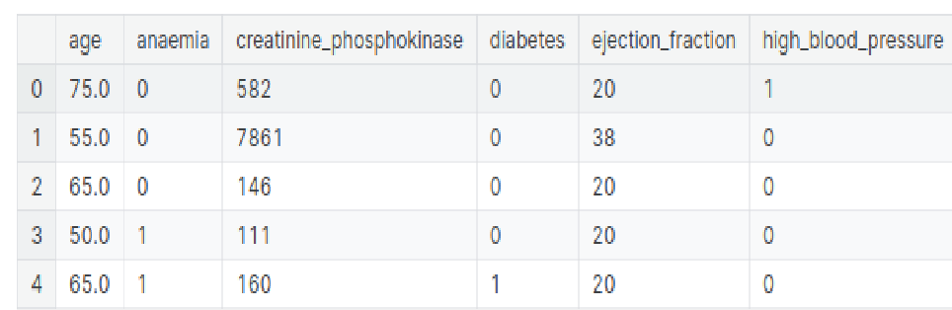

*Figure-8: Features of dataset*

Module 2: **Image Annotation and Augmentation:** Data Augmentation procedures are implemented to increase the already existing image library. For data augmentation, the images are flipped, color-corrected, and rotated to imitate the marine plastic images. Image annotation is an image retrieval process used to label the various parts or sections of an image. This helps in denoting the position of the plastics in an image. Furthermore, cleaning and pre-processing the dataset by removing duplicates, resizing and cropping images to a uniform size, and dividing the dataset into a training dataset, a validation dataset, and test sets are also done to achieve accuracy and reliability.

Module 3: **Model Building:** After obtaining the suitable dataset and data items, and after annotating the data we need a suitable CNN architecture to implement a model based on it. A suitable architecture is selected for the detection task, which typically involves a combination of convolutional layers for feature extraction and pooling layers for down-sampling. It is implemented using the TensorFlow library. Transfer learning techniques may also be used to leverage pre-trained models for improved performance. Once the model architecture is defined, it is trained on the dataset using a set of hyper parameters that define the optimization algorithm, the learning rate, the batch size, and other factors. During training, the model's performance is monitored on a validation set to ensure that it is not overfitting the training data. Once the model is optimized, it is tested on the test set to assess its real-world performance. The trained model can then be deployed in an application or system for object detection.

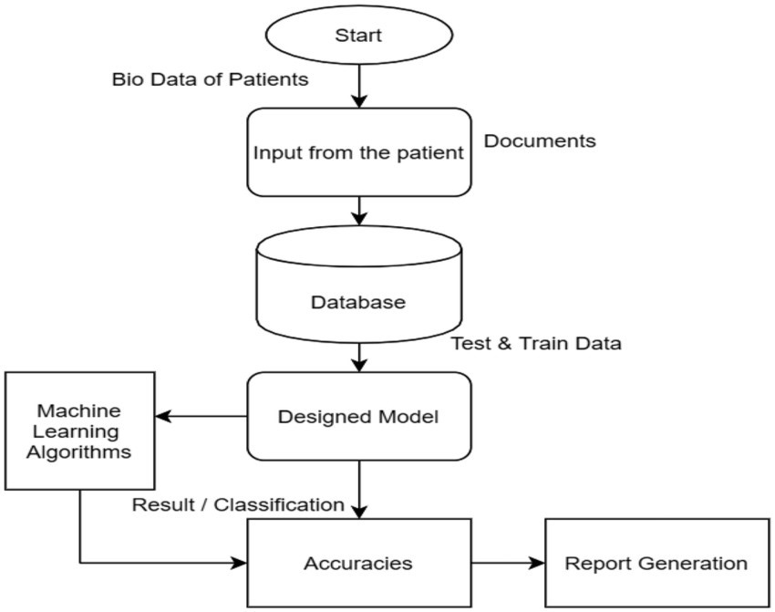

*Figure-8: Flowchart of the model*

Module 4: **Training and Testing:** The model built is now given input data in the form of images, these images are generally resized to reduce its size and make the dataset uniform. The convolutional layer extracts and analyses image features, identifying key components that may serve as identifying characteristics of an object. This process creates a feature map, which contains information about the vector representation of the image that has been captured. The classification layer groups the desired objects that have been detected.

Module 5: Now for the testing phase, the model is given data in the form of images. The model analyses them and detects if it is the desired object or not.

Then the data output is given as per the insights found from the training dataset.

Validation of the data provided and model trained is carried out in his phase.

Module 6: **Evaluation:** The evaluation of a CNN-based object detection model is a crucial step in assessing its performance and accuracy. During the evaluation, the model is typically tested on a separate validation or test dataset, and its performance is compared against a set of predefined metrics to determine its accuracy. In case, the model does not perform well, adjustments are made to its architecture, hyperparameters, or training dataset to improve its performance. Once the model has been evaluated and optimized, it can be deployed for real world object detection tasks. For the initial evaluation phases, the accuracy of the detection was comparatively low and needed a substantial increase. The accuracy of the predictions of the algorithm was later increased by including more marine plastic images in the dataset, incorporating all environmental variables that could impact the image quality and clarity and plastic characteristics. The images in various environments, clarity, quality and conditions were added and the model was trained on them.

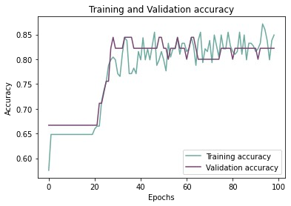

*Figure-8 : Plotting accuracy over epochs for training and validation*

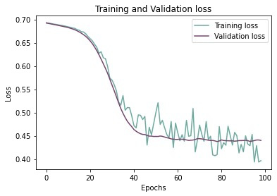

*Figure-9 : Plotting validation and training loss across epochs*

**Module-7 :** By implementing a convolutional neural Network, we have designed a model which detects the underwater plastic. By implementing this algorithm in a machine, we can create objects that can detect underwater plastic which is a threat to marine life. In this, we have used various libraries like TensorFlow which has been used for creating the model for object detection. we have imported keras, layers, and sequential libraries. Keras provides a Python interface for artificial neural Networks whereas layer is a data processing module that takes as input one or more tensors and outputs one or more tensors. In this, we have collected images of underwater plastic as a dataset to train the model for plastic detection and images for aquatic animal detection so that it can distinguish clearly between threat and non-threat. The training of the model is done layer by layer and after training the model, the graph of validation accuracy vs training is depicted which gives a clear depiction of the accuracy of the model. A suitable architecture is selected for the detection task, which typically involves a combination of convolutional layers for feature extraction and pooling layers for down-sampling. It is implemented using the TensorFlow library. Transfer learning techniques may also be used to leverage pre-trained models for improved performance The model was tested with various random image inputs and it clearly depicted the desired result as a threat and non-threat.

# CHAPTER-7

**SYSTEM TESTING**

The testing phase plays a critical role in the System Development Life Cycle. To maximize the benefits of testing and manage its associated costs, it requires careful planning. Test planning focuses on defining the standards for the testing process rather than outlining the product test. System testing is a crucial component of software quality assurance and serves as the final review of the system specifications.

**7.1. INTRODUCTION**

Software testing is a process used to identify the correctness, completeness and quality of the developed computer software. Testing a process is questioning a product in order to evaluate it, where the questions are things the tester tries to do with the product, and the product answers with its behaviour in reaction to probing of the tester.

The testing phase is performed after the coding to detect all the errors and provide quality assurance and ensure reliability of the software. Testing is vital to the success of the system. During testing, the software to be tested is evaluated to determine if the system is performing as expected. Clearly, the success of testing in revealing errors depends critically on the test cases. The different testing strategies employed in this project are explained in this chapter.

**7.2. UNIT TESTING**

In computer programming, unit testing is software verification and validation method in which a programmer tests if individual units of source code are fit for use. A unit is smallest testable part of an application. It is also called as module testing. The goal of unit testing is to isolate each part of the program first and then testing the sum of its parts, integration testing becomes much easier. In our project, we apply this by testing the various modules of the application and also each feature individually.

**7.3. INTEGRATION TESTING**

Integration testing is three phase in software testing in which individual software modules are combined and tested as group. It occurs after unit testing and before system testing. Integration testing takes as its input module that have been tested groups them in larger aggregates, applies tests defined in an integration test plan to those aggregate and delivers as its output the integrated system ready for the system testing. The purpose of the integration testing is to verify functional, performance and reliability requirement placed on major design items. All the different modules of the project are combined and tested.

**7.4. TEST CASES:**

The model built is now given input data in the form of images, these images are generally resized to reduce its size and make the dataset uniform. The convolutional layer extracts and analyses image features, identifying key components that may serve as identifying characteristics of an object. This process creates a feature map, which contains information about the vector representation of the image that has been captured. The classification layer groups the desired objects that have been detected.

Now for the testing phase, the model is given data in the form of images. The model analyses them and detects if it is the desired object or not. Then the data output is given as per the insights found from the training dataset.Validation of

# CHAPTER-8

**RESULT AND DISCUSSION**

**8.1. RESULTS:**

In this study to develop a predictive model for cardiovascular diseases using Advanced machine learning, and the model performed well, with an accuracy of 80%. When compared to baseline models, the ANN model outperformed them, highlighting the effectiveness of deep learning techniques in medical prediction tasks. Significant predictors including age, blood pressure, cholesterol, smoking status, and prior CVD occurrences were found by feature importance analysis, offering important new information about disease risk factors. Strong performance was shown by the model across a range of patient demographics, highlighting the significance of high-quality data and preprocessing. Still, issues with data quality and model interpretability exist, calling for more study. Collaboration and ethical consideration are necessary for the successful clinical implementations.

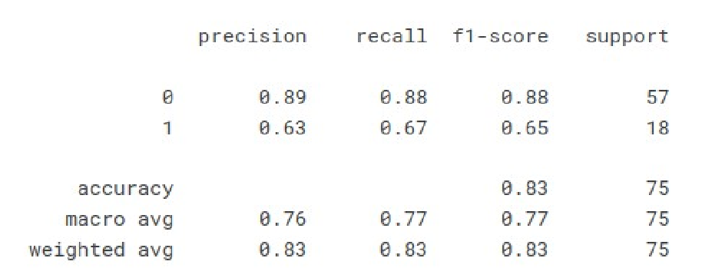

*Figure-10: Accuracy Chart of the model*

**8.1. DISCUSSION:**

The success of the study in developing a predictive model for cardiovascular diseases using advanced machine learning, particularly Artificial Neural Networks (ANN), underscores the potential of deep learning techniques in medical prediction tasks. Achieving an accuracy of 80% demonstrates the efficacy of the ANN model, especially when compared to baseline models. This performance improvement highlights the importance of leveraging sophisticated machine learning algorithms capable of capturing complex relationships within the data. By outperforming traditional models, the ANN model not only enhances predictive accuracy but also offers valuable insights into disease risk factors.

The feature importance analysis conducted as part of the study revealed significant predictors of cardiovascular diseases, including age, blood pressure, cholesterol levels, smoking status, and prior occurrences of CVDs. These findings provide crucial new insights into the multifactorial nature of cardiovascular risk, informing clinicians and researchers about the key variables to consider in risk assessment and management. Moreover, the robust performance of the model across various patient demographics underscores the importance of high-quality data and rigorous preprocessing techniques in ensuring the reliability and generalizability of predictive models. However, despite the promising results, challenges remain in the areas of data quality and model interpretability. Issues such as missing data, data heterogeneity, and potential biases may impact the reliability of predictions and hinder the adoption of the model in clinical practice. Furthermore, the inherent complexity of deep learning models raises concerns about interpretability, limiting clinicians' ability to understand the rationale behind predictions and trust the model's recommendations.

Addressing these challenges requires collaborative efforts between data scientists, clinicians, and healthcare stakeholders. By fostering interdisciplinary collaborations, researchers can address data quality issues, develop robust preprocessing pipelines, and enhance model interpretability through techniques such as feature visualization and sensitivity analysis. Additionally, ethical considerations regarding data privacy, informed consent, and algorithmic bias must be carefully navigated to ensure the responsible and equitable deployment of predictive models in clinical settings. Only through concerted efforts and ongoing research can the full potential of advanced machine learning techniques be realized in improving cardiovascular healthcare outcomes.

# CHAPTER-9

**CONCLUSION**

**9.1. CONCLUSION:**

In conclusion, there have been notable developments in the field of cardiovascular healthcare as a result of the project "Predictive Modeling of Cardiovascular Diseases Using Artificial Neural Networks (ANN)". The research has significantly improved risk assessment and individualized management of cardiovascular diseases through the creation and application of ANN-based predictive models. Based on a variety of patient data sets, such as demographics, medical histories, lifestyle factors, and clinical biomarkers, the study's findings highlight the potential of ANN models in precisely predicting the incidence of cardiovascular illnesses. The ANN model proves to be efficacious in identifying individuals who are at risk of cardiovascular illnesses, as evidenced by its high predictive accuracy, sensitivity, and specificity. This, in turn, allows for prompt treatments and preventive measures. All things considered, the "Predictive Modeling of Cardiovascular Diseases Using ANN" study represents a major advancement in the use of machine learning methods to preventative healthcare tactics. This research advances the ability to identify risk and enables tailored therapies, which helps to reduce the worldwide burden of cardiovascular diseases and improve health outcomes for those who are at a risk.

Moreover, the implications of this study extend beyond individual patient care to population health management. By leveraging ANN-based predictive models, healthcare systems can proactively identify populations at elevated risk of CVDs, enabling the implementation of tailored preventive strategies at a broader scale. This proactive approach not only enhances healthcare resource allocation but also contributes to the overall reduction of the global burden of cardiovascular diseases.

**REFERENCES**

1. Mehmood, Awais, Momina Masood, Tahira Nazir, Munwar Iqbal, Zahid Mehmood, Aun Irtaza, and Marriam Nawaz. "Prediction of heart disease using deep convolutional neural networks." Science and Engineering in the Arabian Journal 46(4) (2021): 3409–3422.
2. Deep learning approach for prediction of heart disease using data mining classification algorithm deep belief network," by T. Karthikeyan and V. A. Kanimozhi, was published in 2010. Journal of Advanced Research in Science, Engineering, and Technology International, Vol. 4, No. 1, 2017, pp. 3194-3201.
3. Kishore, Yogita Hambir, Maninder Punia, Ajay Kumar, Abhay, and Karan Singh."Heart attack prediction using deep learning." Journal of Engineering and Technology (IRJET) International Research Journal, Volume 5, Issue 4, 2018, 2395-0072.
4. Ashraf, Mohd, M. A. Rizvi, and Himanshu Sharma. "Deepneural network-based enhanced prediction of heart disease." Asian Journal of Technology and Computer Science, 8, no. 2, 2019, pp. 49–54.
5. Jing Guo, Pan, Yuanyuan, Minghuan Fu, Biao Cheng, and Xuefei Tao. "Enhanced deep learning assisted convolutional neural network for heart disease prediction on the internet of medical things platform." 2020 IEEE Access 8:189503–189512.
6. Dutta, Aniruddha, Scott T. Acton, Meheli Basu, and Tamal Batabyal. "An efficient convolutional neural network for coronary heart disease prediction." The 2020 issue of Expert Systems with Applications 159: 113408.
7. Simanta Shekhar, Sarmah. "An efficient IoT-based patient monitoring and heart disease prediction system using deep learning modified neural network." 2020 IEEE Access 8: 135784–135797.
8. Kyung-Sup Kwak, Ali, Farman, Shaker El-Sappagh, SM Riazul Islam, Daehan Kwak, Amjad Ali, and Muhammad Imran. "A smart healthcare monitoring system for heart disease prediction based on ensemble deep learning and feature fusion."2020; Information Fusion 63: 208–222.
9. S. Nithyavishnupriya, P. Ramprakash, R. Sarumathi, and R. Mowriya. "Heart disease prediction using deep neural network." Pages. 666–670 in 2020 International Conference on Inventive Computation Technologies (ICICT). IEEE, 2020.
10. S. Nithyavishnupriya, P. Ramprakash, R. Sarumathi, and R. Mowriya."Heart disease prediction using deep neural network." Pages. 666–670 in 2020 International Conference on Inventive Computation Technologies (ICICT). IEEE, 2020.
11. Kannagi, V., M. Rajkumar, I. Chandra, K. Sangeethalakshmi, and V.Mohanavel. "Logical Mining Assisted Heart Disease Prediction Scheme in Association with Deep Learning Principles." In 2022 International Conference on Electronics and Renewable Systems (ICEARS), pp. 14091415. IEEE, 2022.
12. Shinde, Surai, and Juan Carlos Martinez-Ovando. "Heart Disease Detection with Deep Learning Using a Combination of Multiple Input Sources." In 2021 IEEE Fifth Ecuador Technical Chapters Meeting (ETCM), pp. 1-3. IEEE, 2021.
13. Waqar, Muhammad, Hassan Dawood, Hussain Dawood, NadeemMajeed, Ameen Banjar, and Riad Alharbey. "An efficient SMOTE-based deep learning model for heart attack prediction." Scientific Programming 2021 (2021).
14. Shadab Akhtar, Hussain, Md. Suaib, Santosh Kumar Nanda, SusmithBarigidad, and Niranjan K. Ray. "Novel Deep Learning Architecture for Predicting Heart Disease using CNN." Pages. 353–357 in the 19th OITS International Conference on Information Technology (OCIT), 2021. IEEE, 2021.
15. "Heart diseases prediction using deep learning neural network model," bySharma, Sumit, and Mahesh Parmar. International Journal of Cutting Edge Technology and Investigating Engineering (IJITEE), Volume 9, Issue 3, 2020, pages 124–137.